(Approx. 1254 words)

Windows 10 Tips and Tricks
By Dorothy Fitch, Editor, GVR Computer Club
October 2020 issue, Green Bytes
https://www.ccgvaz.org/
dmfitch (at) cox.net

Here are some tips and tricks for using Windows 10. Try them out!
1. How to pin items to the Taskbar or Start menu
It can be handy to have your most frequently used apps just a mouse-click away. You can place buttons to open or switch to them on the Taskbar that runs along the bottom of your screen, or in the Start menu, which is what you see when you click the Windows button at the left edge of the Taskbar.
To put a program in one of these places, click the Start button. Scroll down to find the program you want to add in the list. Right-click the name of the program and you will see these choices:
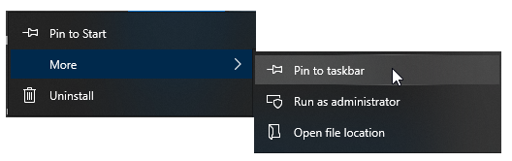
You can click Pin to Start on the left side to add it to the Start menu. Or you can click Pin to taskbar to place it at the bottom of your screen. Either way, you'll have an easy way to get to your programs.
There are probably already shortcut icons on your Desktop to start up your programs, but I find the Desktop gets too cluttered and I have hidden all the Desktop items. To do this, right-click anywhere on the Desktop. Choose View, at the top, and then uncheck Show desktop items.
2. How to add Search and Task View to the Taskbar
Here are a couple of handy tools you can add to your Taskbar.
A. You can add a Search button or even a Search box. Right-click the Taskbar and look for Search, near the top. Your choices are to hide Search, show the icon, or show the text box.
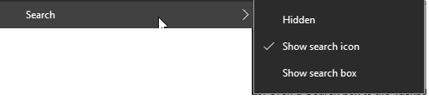
If you choose the icon, you can click it to get a search box. You can filter the search to include All, Apps, Documents, Web, Folders, and more. Select what you want to search by clicking on the desired area.
B. You might also want to add the Task View button. To do this, right-click the Taskbar and select the Show Task View button. When you click the Task View button, all of your open files and folders appear on your screen and you can click to switch to any of them.
The left side of your Taskbar might now look like this, with the Start button first, then the Search button, then the Task View button. With these options available, it's easier to get around Windows 10.

3. Windows 10 Major Update and what I had to correct
Your Windows 10 computer may have just been updated a new version. In mid-September, my new version was installed: v. 2004. That sounds like it's about seven years old, but Microsoft names major updates after a year and a month, so it is only about five months old (2004 means April 2020). [To find your version number for Windows 10, go to Settings>System>About.]
I haven't read anything about this update, but I noticed a couple of differences right away. One was that every time a search for something in File Explorer came up empty, my entire screen flashed black, inverting most of the colors. It was very momentary, but rather disturbing. I finally figured out where to change that setting.
It's under Audio, of all things. I had thought that perhaps I was seeing this screen flash because most of the time I have my sound turned off. But even after unmuting my sound, it persisted. I was finally able to turn it off by going here: Settings>Ease of Access> Audio. (To get to Settings, click the Windows button, then the gear.)
Below is what part of that setting looks like (click to enlarge it). Note the choices at the bottom for Show audio alerts visually. I found mine set to Flash the entire screen! I know I never chose that setting and can only imagine that Microsoft changed it during the update process. Now, it's back to something better. Whew!
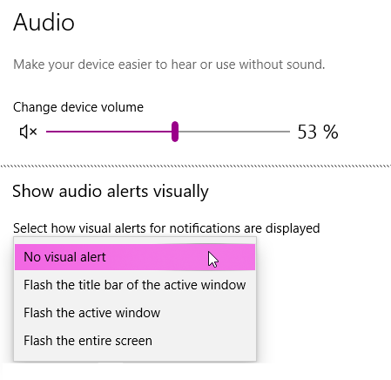
4. How to customize colors and backgrounds
Here is another issue that occurred after that major Windows 10 update. My Taskbar was very light-colored and all the tabs in my browser were black! That was definitely not what I had before, and I didn't like it. I poked around and found the settings needed to put them back to what I wanted.
I found them in Settings>Personalization>Colors. I chose Dark for default Windows mode and Light for default app mode. I'm not sure about the terminology being used, but it didn't matter. I was able to click the radio buttons and see the colors change immediately, so I knew when I had made the right choices.
You can also choose to have a slideshow of images on your desktop. Go to Settings>Personalization>Background to choose a folder to select the images from, set the timing, and explore other options.
Click on these images to enlarge them.
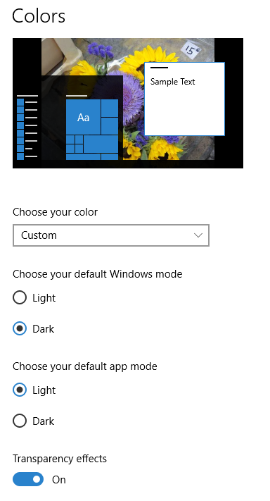
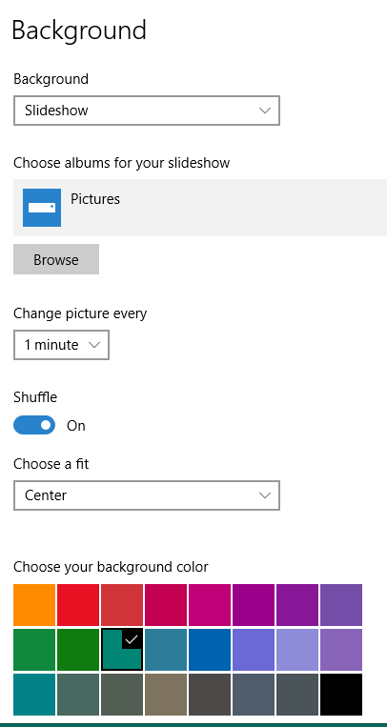
It's fun to change your colors and backgrounds once in a while to give your computer a fresh look.
Note: In Windows 10, you can select just a single folder for background photos. Choosing that folder doesn't automatically include images in its subfolders. To enjoy a wider selection of photos, I created a new folder and copied a few thousand images into it to be chosen at random for background images.

5. How to restore those fun Windows 7 games
Remember those fun games that came with Windows 7—Mahjong Titans, FreeCell, Minesweeper, Hearts, Solitaire, to name a few? You can install these games on Windows 10 and they work just fine. However, Microsoft tends to delete them when it does a major update (it just did it with my 2004 update in September). Advice: keep the download file (or this email) so you can always get them back. You can choose which games you want to install.
To get the games, click here to go to the website, then click the link shown below. (Note that there are several other Download buttons on this page, but they are ads, so stay away from them.)
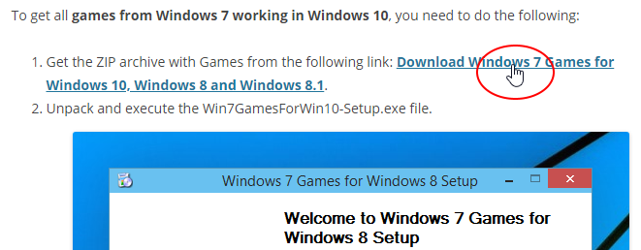
Then look for and click this link:
Download 'Windows 7 games for Windows 10'
Size: 146.66 Mb
Download link: Click here to download the file
6. How to manage multiple documents with checkboxes
You can add checkboxes to items in folders in Windows 10. Click the View tab in any folder and look for the Item check boxes option in the Show/hide area (shown circled in red in the image below, which you can click to enlarge).
Checking this option puts a check box next to each item in the folder. This may make it easier than using the mouse to select several items at once. Then you can copy, delete, or open them in one easy action.
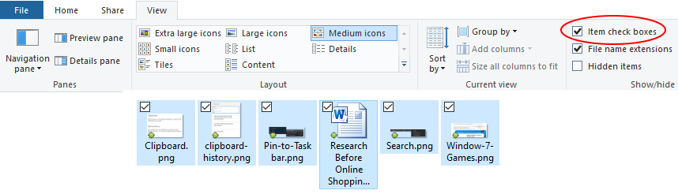

7. How to use multiple clipboards
Did you know that Windows 10 supports multiple clipboards? After copying text or images, you can choose which one you want to paste from a list of recently copied items. First you have to turn on the feature. Go to Settings>System>Clipboard. Turn on the button for Clipboard history.
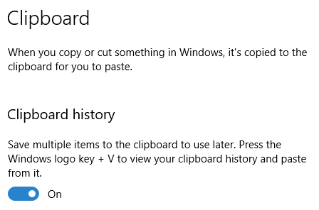
Now, when you want to paste an item from your Clipboard history, hold down the Windows key on your keyboard (it's between Ctrl and Alt) and press the V key. You will see a list of the things you can paste and click on the one you want.

Enjoy exploring some of these Windows 10 features!

